Project Report: Online Cottage Food Sales – 2018 Trial with the Alaska Food Hub
Prepared for the Alaska DEC and Anchorage MUNI
by Robbi Mixon, Local Food Director at Cook Inletkeeper
Contact Information: Robbi Mixon, 907-235-4068 ext. 23 or robbi@inletkeeper.org
Website: www.alaskafoodhub.org
Online Sales Platform: https://alaskafoodhub.localfoodmarketplace.com/

Narrative:
What is a Food Hub? Producers place items for sale each week and customers order through an internet platform. Products are delivered to a central location where customers come and claim their items. This cycle repeats. Here’s a great explainer video: https://www.youtube.com/watch?v=kTtT3SHliDs
The Alaska Food Hub (formally the Kenai Peninsula Food Hub) opened its online platform in 2016, for the sale of 100% locally produced, harvested, and crafted products. The majority of products sold through the Food Hub are produce – vegetables and fruits, with seafood, poultry, shellfish, and some value added products making up the rest.
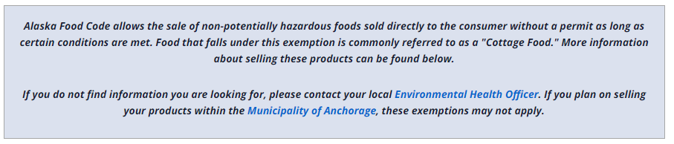
Prior to opening, a Request for Variance of DEC Cottage Food Policy 18.AAC 31.012 (a)(6) was made in February 2016, allowing for sales online, removing the face to face component. This was denied and we operated our first two seasons with no cottage food products. In 2018, in response from vendor requests to sell cottage food products, requested the variance again, providing a variety of information regarding operations, food handling, and source and ingredient identification. Through collaborative conversations with both the DEC and Anchorage MUNI, the Alaska Food Hub was granted trial variances for cottage food sales through the internet.
Both agencies required the following:
- Ensure compliance of AMC 16.60.050 requirements, with the exception of AMC 16.60.105.B2
- Food Safety Manager Certification
- Permitting (both the Food Hub and producers)
- Make Policy Updates including labeling of: Ingredients, production date, name, address, phone
- Temperature Monitoring
- Sales Tracking
- Written Summary
- Maintain Shellfish Tags
Implementation:
- Ensure compliance of both agencies cottage food codes
- Food Safety Manager Certification – received in May
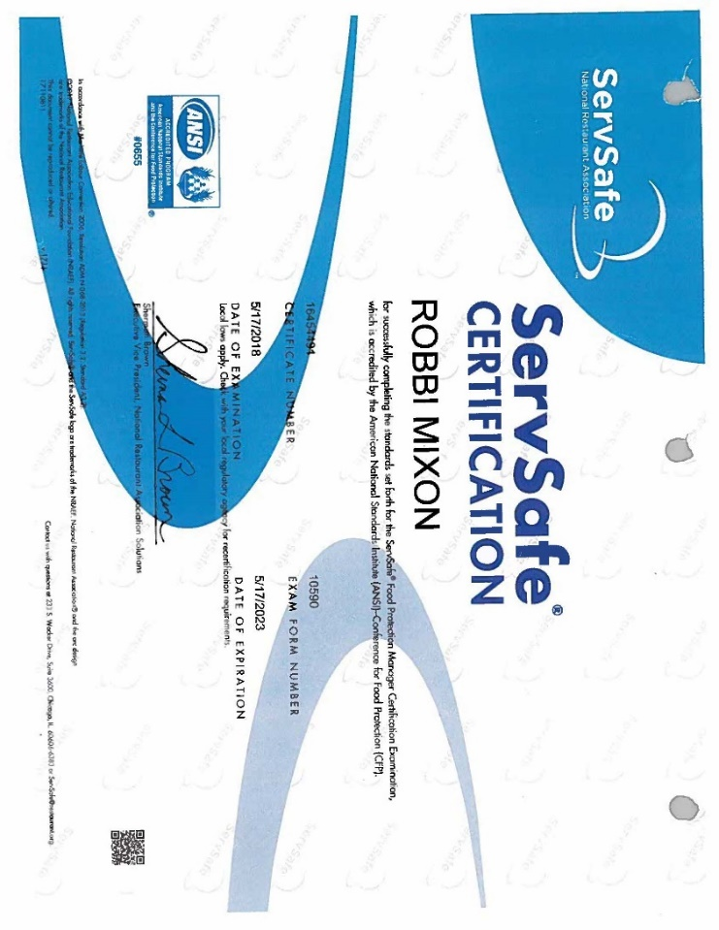
- Permitting (both the Food Hub and producers)
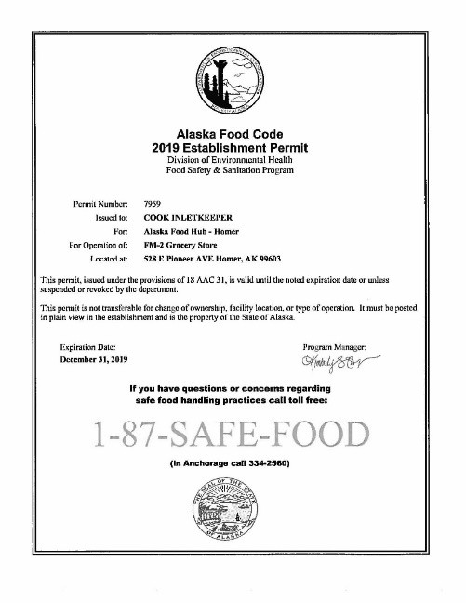 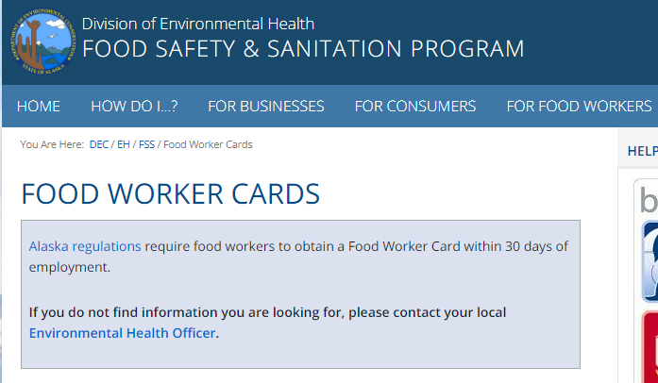
Food Handler permits were required prior to any sale of cottage foods by producer.
- Make Policy Updates including labeling of: Ingredients, production date, name, address, phone; from the Alaska Food Hub Policy Manual:
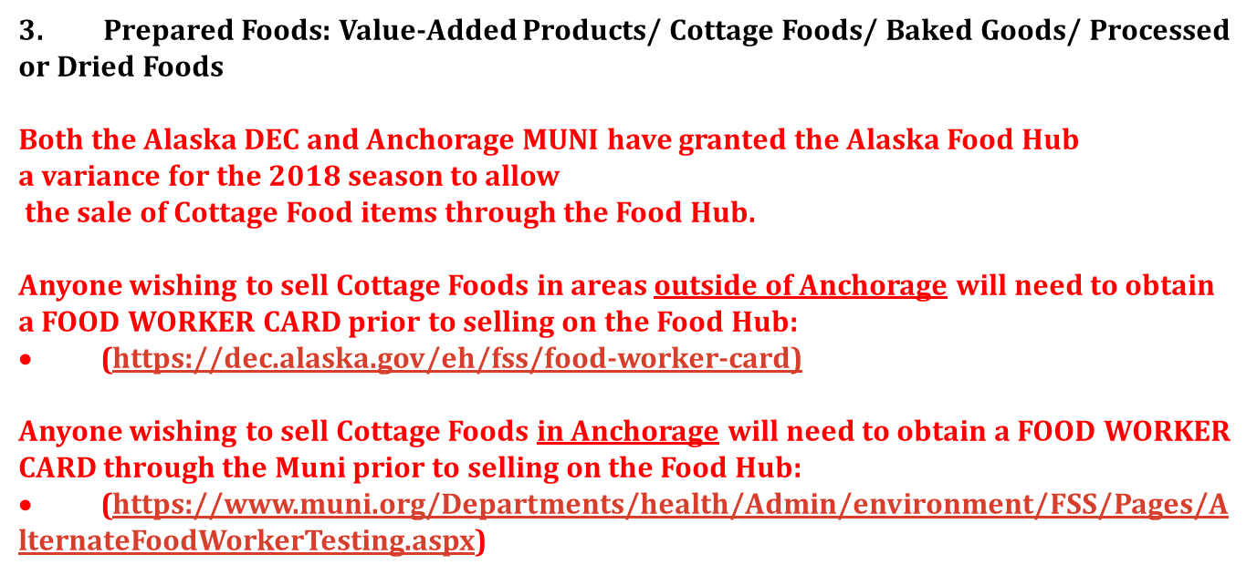
- These rules apply to ALL prepared food, including cottage food and those prepared in a DEC/MUNI kitchen. Online Listings & physical labeling on all food products including jams, jellies, pickles, kimchi, baked and dried goods and the like, must include:
  - Name of product (i.e., Apple and Kale Salad)
  - List of all ingredients
  - Name, address and phone number of where food was prepared, and/or business license number.
  - Production date (if shelf stable, month/year is acceptable
  - Storage instructions, if not shelf stable
  - Vendors of baked goods are required to sell items individually wrapped
  - If cottage food, label/list with the following statement: “THES PRODUCTS ARE NOT SUBJECT TO STATE INSPECTION”
All items that are not exempt by Cottage Food laws and require a DEC/MUNI kitchen must have all DEC/MUNI permits, business license and carry liability insurance, and be on file with Food Hub. It is your responsibility to obtain clearance on food products from the DEC/MUNI prior to selling.
Producers outside of Anchorage are responsible for working directly with the DEC to insure compliance with Alaska Statute 18 AAC 310 and other applicable regulations, and must provide a copy of their DEC certification and proof of liability insurance to the Food Hub Coordinator.
Anchorage Producers selling cottage foods defined in AMC 16.60.050, must ensure that they [FD1] are meeting all of the requirements of the regulations with the exception of AMC 16.60.105.B2.
Fruits, vegetables, and herbs used in processed foods should be primarily grown or wild-crafted by the producer, or purchased from a local grower
Prior to selling any of these items, including cottage food, you must clear it with the Food Hub Coordinator.
A DEC/MUNI approved kitchen is not required for the preparation of baked goods including pastries, cookies, muffins, breads, pies and granolas, preserves, jams and jellies, honey, fruit syrups, dried herbs and teas, and herbal vinegars.
This does not include items that require refrigeration like cream pies, cheese cake, or items with all meats including fish and poultry. All vendors must be familiar with and follow all aspects of DEC/MUNI regulations. These regulations (DEC- Statute 18 AAC 31.012; MUNI- AMC 16.60.050[FD2] ) can be found at (LINKS PROVIDED)
Here’s what a cottage food listings looked like on the store front:
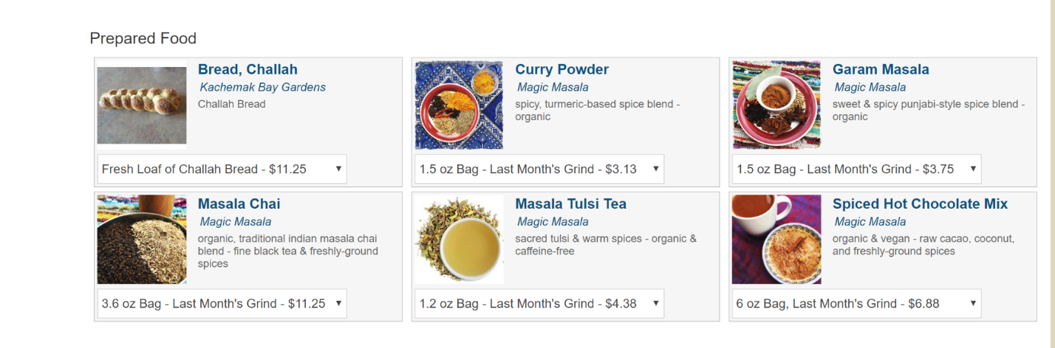
Once you clicked on a product, the following would be displayed:
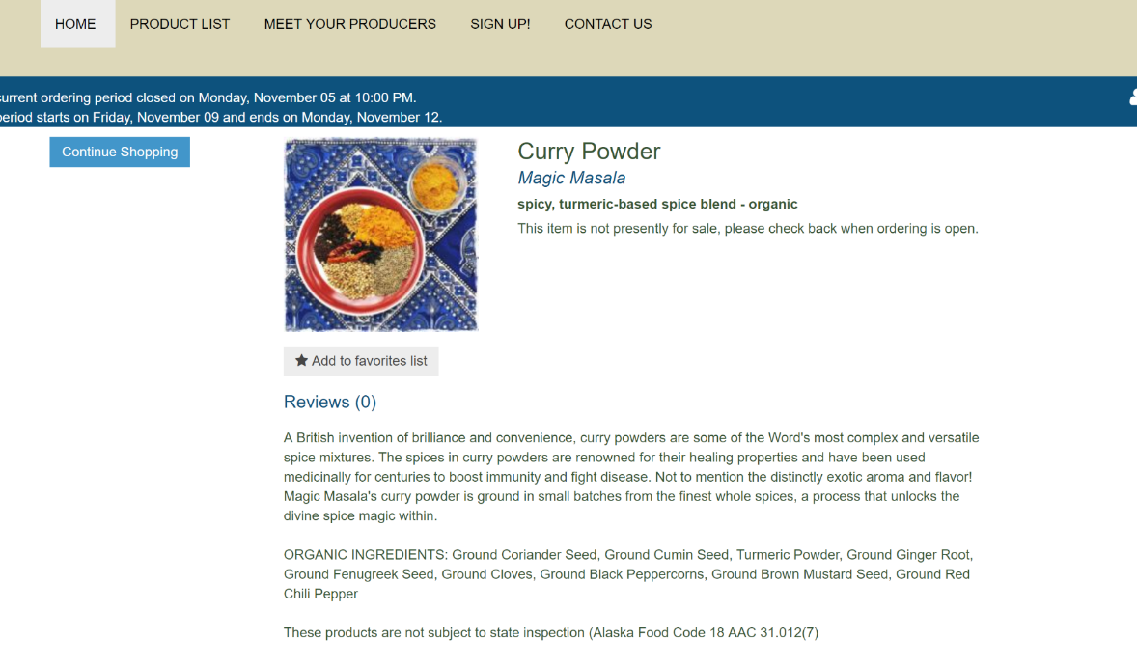
For more information, including contact details, on a producer, customers can find profile information on producer pages:
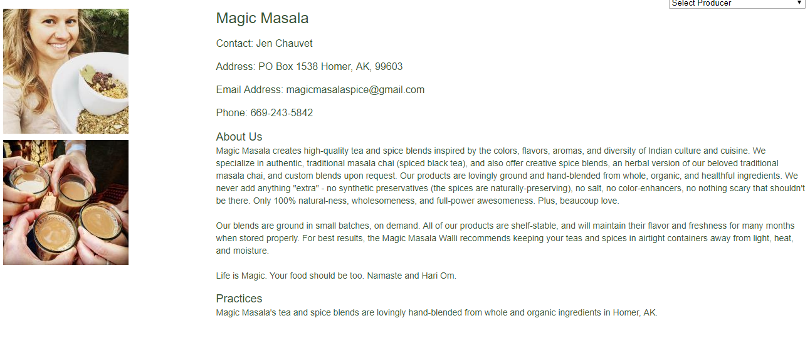
- Temperature Monitoring of all products requiring refrigeration
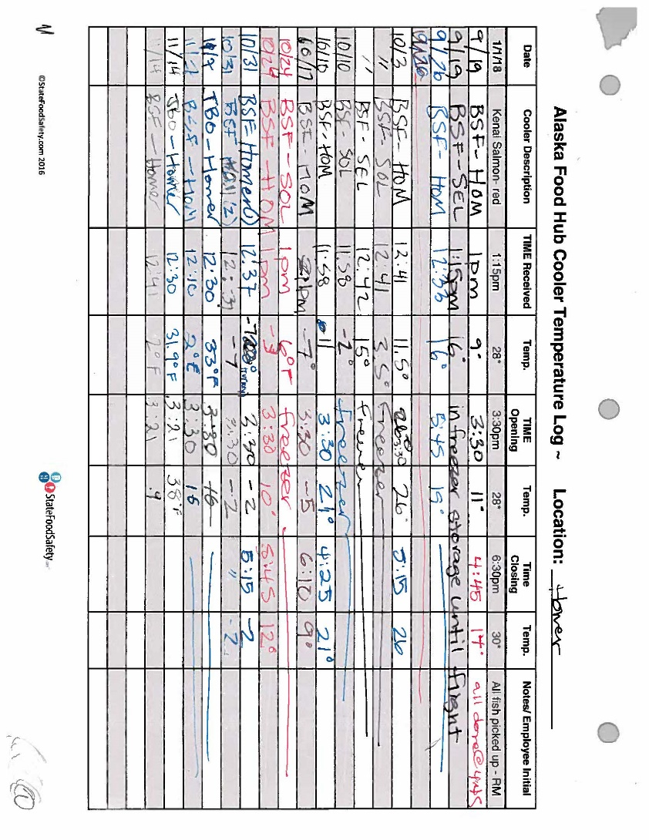

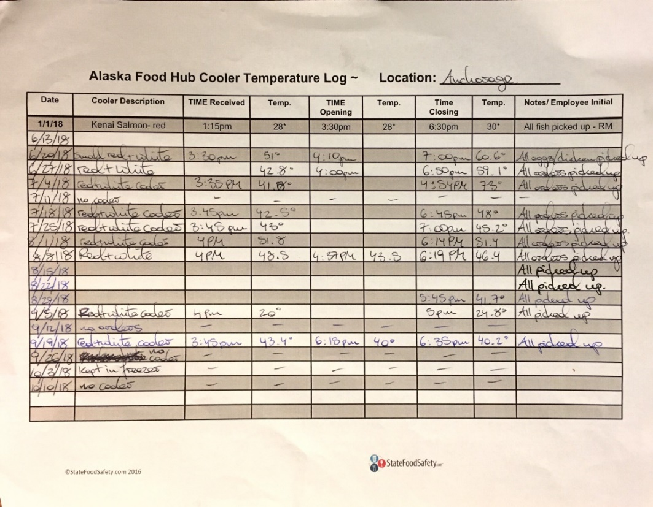
Each food hub location tracked each cooler, noting the date, product/producer/cooler description, time received and temperature, time of opening food hub and temperature, and finally the time and temperature of cooler upon removing the last item. Notes were made to further explain operations when needed. Logs were reviewed weekly to assure proper holding temperatures.
- Sales Tracking (Source Identification)
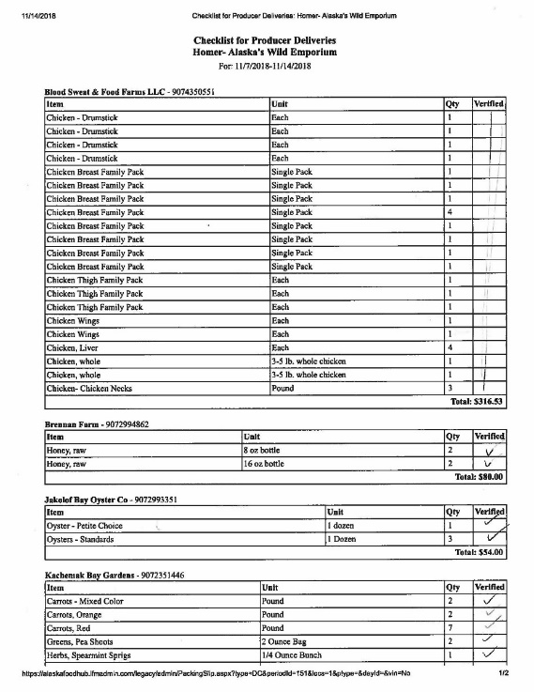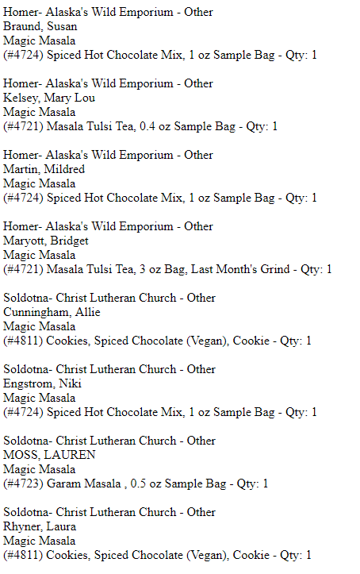
All sales tracking are managed by the online platform. Any product can be traced to a producer through weekly reports (via administrative or producer portals). All products come labeled with at least the producer’s name. All cottage food or prepared food items require labeling as outlined above (see policy revisions). Products are inspected for quality and labeling when they are dropped off by producers. Records are maintained indefinitely.
- Written Summary - this report serves to comply with written summary requirement. We also represented results to the Alaska Food Safety Advisory Committee during the January 15, 2019 meeting.
- Maintain Shellfish Tags – shellfish tags were attached to each order; tags were maintained by Margo Reveil of Jakolof Bay (also a member of the Food Hub Advisory Committee) and accessible anytime requested. (NOTE: no shellfish was sold in Anchorage this season)
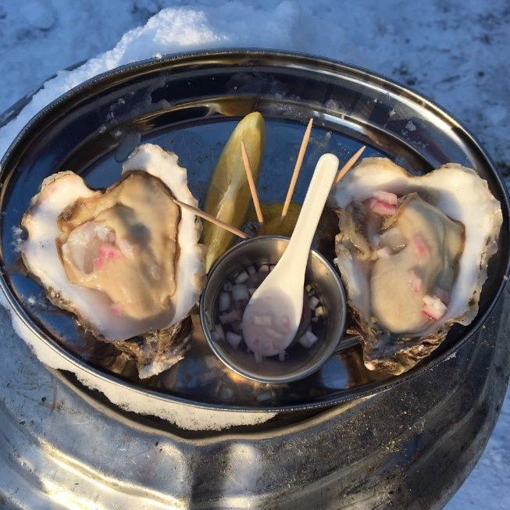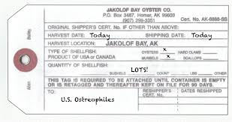

Outcome:
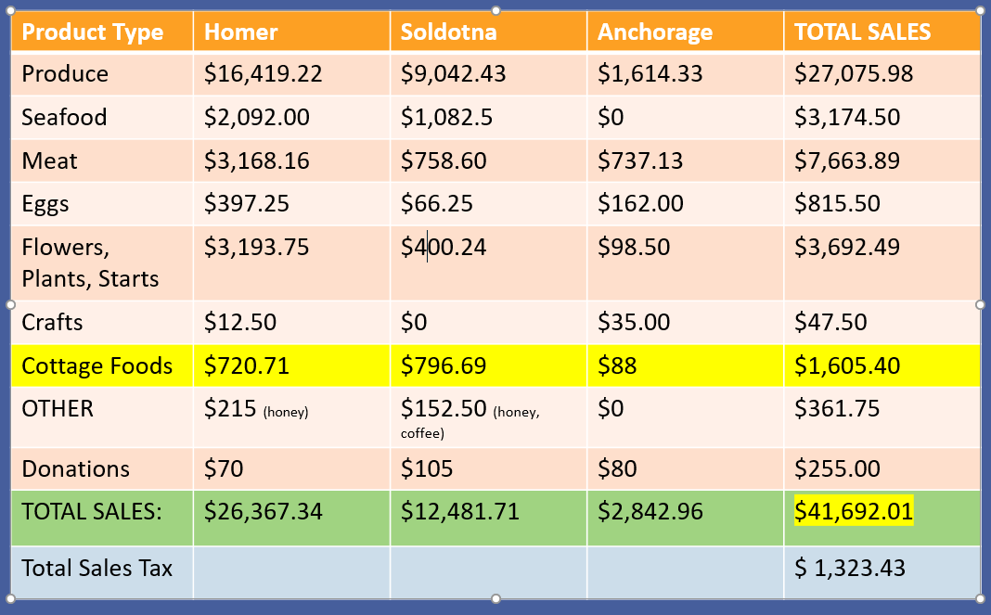
Despite the demand by producers to sell cottage foods through the online platform, we had much less participation than we anticipated. As seen above, we had just over $1,600 in cottage and prepared food sales across our three locations. We did not run into any issues regarding quality, labeling, or difficulties communicating with producers. No food borne illness was traced to Alaska Food Hub sales.
While we hope this variance project paves the way for greater opportunities for small scale food producers, we recognize that such a small sample may not warrant changes in statute yet. We will continue to monitor progress, track and address issues collaboratively with the DEC and MUNI, and are available to answer any further questions. Thank you for the opportunity and we look forward to working together during our 2019 season and beyond.

